DAT 515 uCertify Lab Activity Worksheet

Module Labs
Module 4
4.5.1
4.7.1
4.9.1
5.2.1

Lab Screenshots
4.5.1
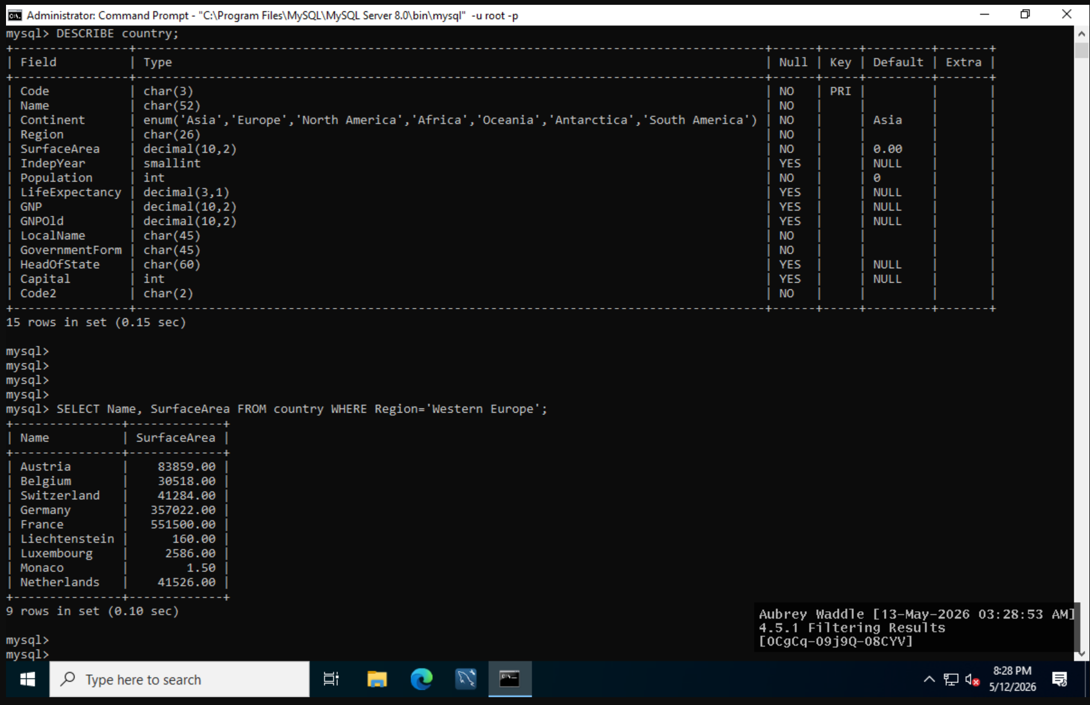
4.7.1
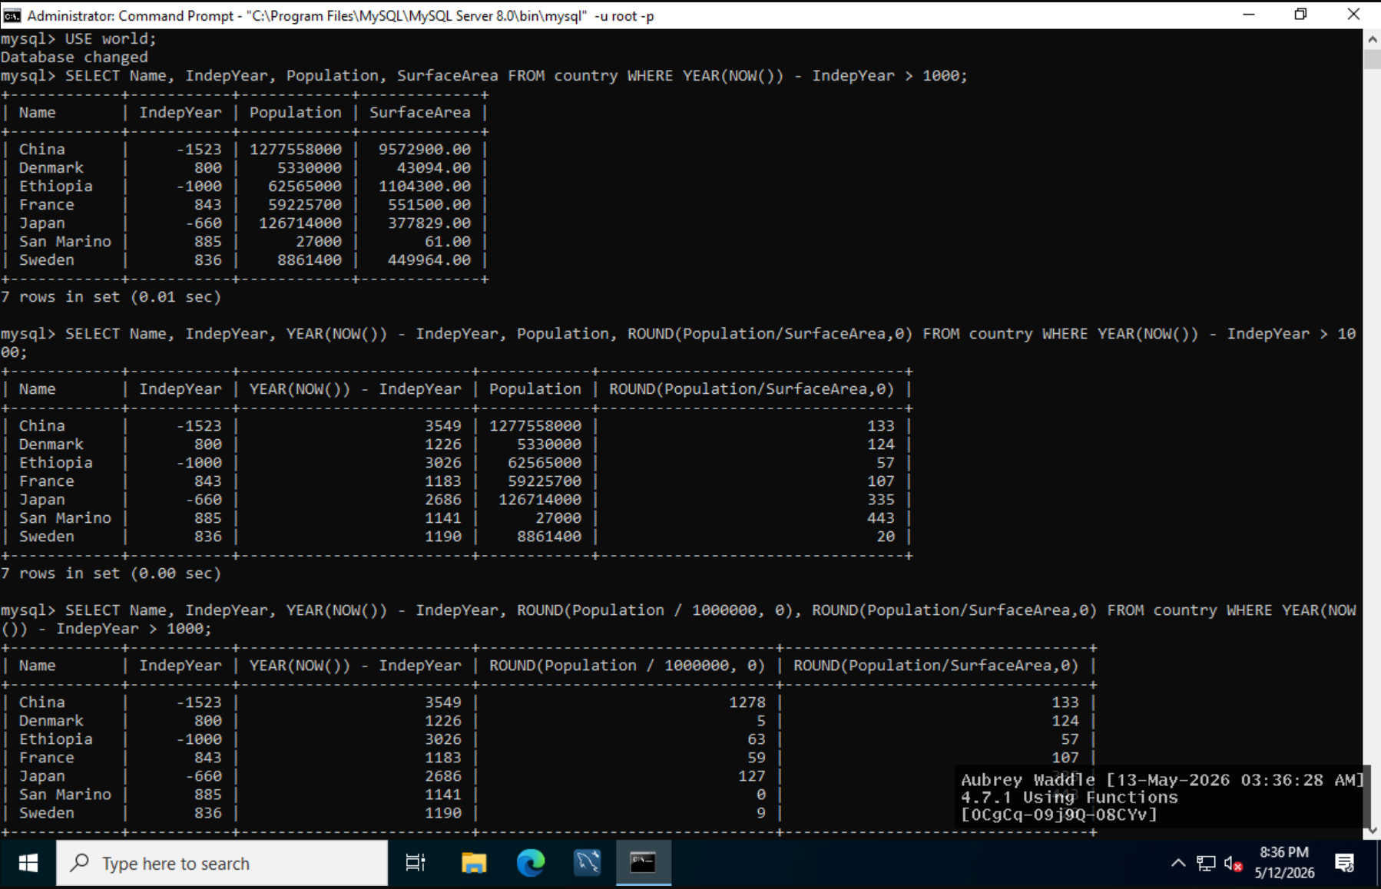
4.9.1
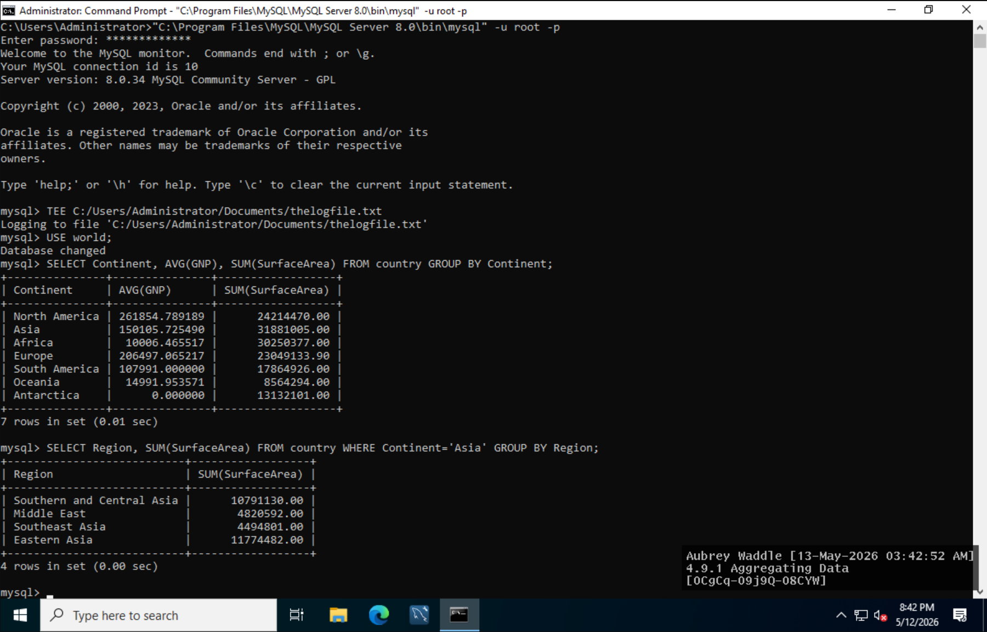
5.2.1
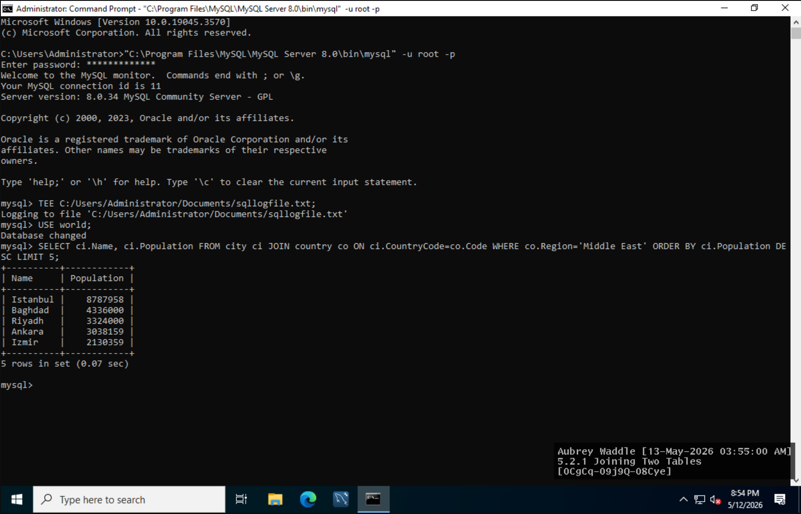

Lab Reflection
- Briefly reflect on your work in this week’s labs. Discuss the tools and techniques you used and the visualizations or processes you created, noting any similarities or differences. What type of audiences would these skills and techniques be appropriate for, or in what situations would they be useful?
4.5.1
This lab taught me how to sort query results properly using the SELECT and WHERE lines in the MySQL command prompt. Using the DESCRIBE statement I learned how the nation table was created. I then filtered the data to include just Western European countries using the Region field. This lab was a nice review of how to use SQL conditions to extract the data we desire from massive data sources.

4.7.1
In this lab I used MySQL functions in SQL queries to manipulate and analyze data in the global database I practiced calculation of nation age, population density and rounded population data utilizing functions such as YEAR(), NOW() and ROUND(). This activity has increased my knowledge on how to use SQL built-in functions to transform raw data into a more usable analytical result.

4.9.1
For this lab, I have used the AVG() and SUM() method to aggregate the data in the nation table. I used the WHERE. I divided up the data in continents and regions, and estimated characteristics like average GNP, total surface area. The main purpose of this experiment was to show how aggregate queries may be used to summarize and analyze patterns in huge databases.

5.2.1
In this lab I practiced to join similar tables in MySQL with JOIN command. I connected city and nation tables to get population stats for middle eastern cities. I think this lab reinforced well the fact that relational databases use keys and connections to connect comparable data sets together to produce more complete results to queries.

These labs have a real life application in database administration and analytics as they teach how to correctly access, manage and analyze company data using SQL. These approaches are prevalent in reporting systems and enterprise databases and business intelligence where precise querying and relational data analysis are important.

